Iowa Pork Producers Association
Environmental Steward Award Winners

2023
Heemstra, Dennis & Lori - Primghar

2022
Weymiller, Ross & Morgan - Waukon

2021
Wegener, Todd & Mary Kay – Fenton

2020
Ehlers, Mike & Michelle - Marathon

2019
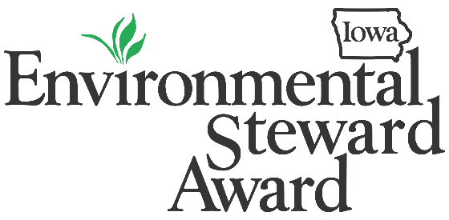
Ditch, Matt & Melissa - Center Point

2018
Berger, Steve - Wellman

2017
Stout, Rob - Washington

2016
Bader, Ben & Anna – Jesup

2015
Huber, Joel & Laura - Huber Crops & Chops Inc. – Wellman

2014
Hunter, Brian & JoAnne – Hunter Finishing - Scranton

2013
Wessling, Bruce & Jenny – Wessling Ag - Grand Junction

2012
Russell, Jason - Russell Brothers, LLC - Prairieburg

2011
Reed, Ryan & Lana - Ottumwa

2010
Bice, Rod & Missy - Woodward

2009
Juergens, Peter & Aaron - Dedham

2008
Nath, Roger & Renee - Hartley

2007
Nothem, Mike & Becky - Remsen

